Exercise 1:

Inventory Management System

1.Understand the Problem:

why data structures and algorithms are essential in handling large inventories.
Imagine managing a warehouse with millions of items. If someone needs to find, update, or delete a product, they need it done now. But if your system is forced to hunt through an unsorted list line-by-line? Everything grinds to a halt. Shipping gets delayed, restocking backs up, and the whole operation turns into a massive headache. That’s where solid DSA comes in—it keeps things lightning-fast, no matter how massive the inventory grows.

types of data structures suitable for this problem.
You could use an ArrayList, but it’s really only good for simple lists where you don't mind scanning through items one by one. The problem is that finding a specific product takes O(n) time, so the bigger your inventory grows, the slower your system gets. A HashMap is the convenient data structure. It organizes data into quick "key-value" pairs. If you use the product ID as your key, you can instantly find, add, update, or delete that item. This drops the work down to O(1) constant time, keeping everything lightning-fast no matter how much stock piles up.

2. Setup:
To build this, just set up a basic Java project named WarehouseInventorySystem. All you really need are two main files to get started: Product.java to define your items and InventoryManager.java to handle the actual logic.
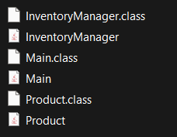

3.Implementation:
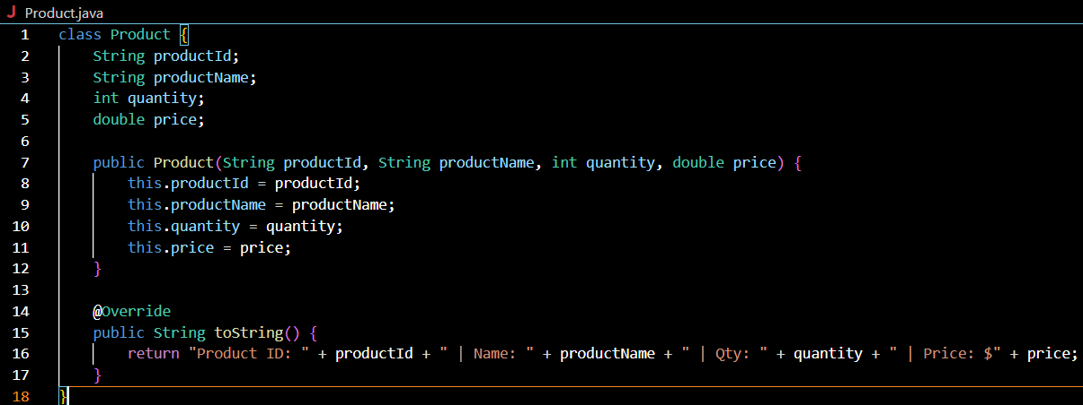
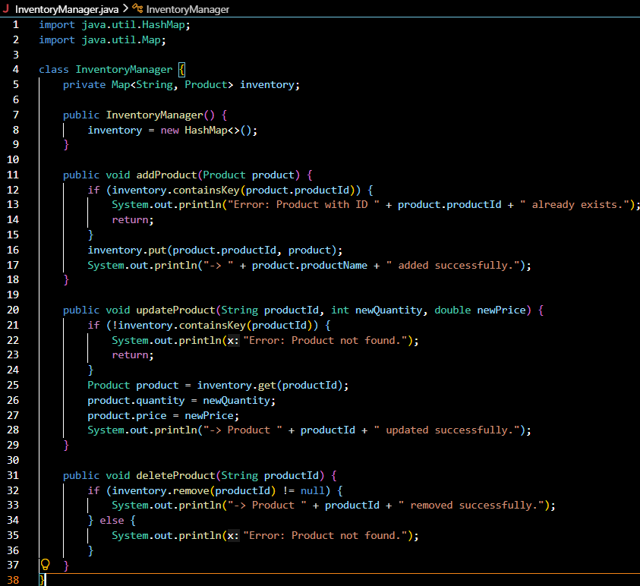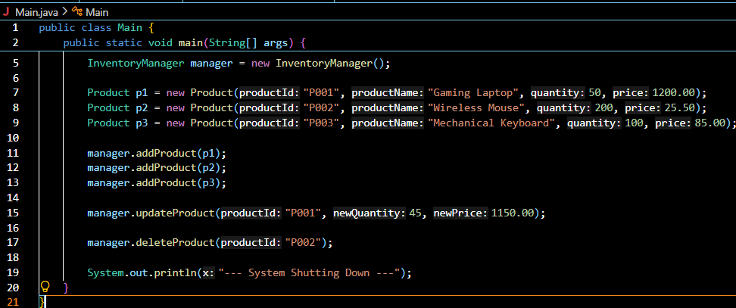
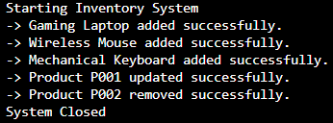

4.Analysis:
Switching to a HashMap makes adding, updating, and deleting items practically instant, bringing your response times down to a flat $O(1)$. In a real warehouse setting, the main things you need to watch out for are handling multiple workers updating stock at the same time so the system doesn't crash, and tweaking your data types to save memory as your inventory scales.

